ECA5403-ELECTROMAGNETIC FILEDS AND WAVES
S. Rupika
192512398
C02-9

Exp no:9 Implementation of Magnetic-Field Boundary Conditions between Two Dielectric Media and Determination of Relative Permeability
Aim:
To implement magnetic-field boundary conditions between two media and determine the relative permeability of the unknown medium.
Software required:
•MATLAB (R2018 or later)
Test Case (i) – Magnetic Boundary Conditions and Determination of the Relative Permeability
Apply the boundary conditions H2t = H1t and B2n = B1n at the interface, determine the relative
permeability of medium 2 from the measured normal H-field and compare it with the reference value.
MATLAB Program:
clc;
clear;
close all;
%% Magnetic-Field Boundary Conditions between Two Media
mu0 = 4*pi*1e-7;
% Input data
% H/m
mur1 = input('Enter relative permeability of medium 1: ');
H1t = input('Enter tangential H-field H1t (A/m): ');
B1n = input('Enter normal flux density B1n (T): ');
H2n_meas = input('Enter measured/assigned normal H-field H2n (A/m): ');
mur2_ref = input('Enter reference relative permeability of medium 2: ');
% Permeability of the two media
mu1 = mu0*mur1;
mu2_ref = mu0*mur2_ref;
% Boundary conditions for zero surface current
H2t = H1t;
B2n = B1n;
% Determine relative permeability from measured H2n
mur2_calc = B2n/(mu0*H2n_meas);
% Theoretical normal H-field using the reference permeability
H2n_theory = B2n/mu2_ref;
% Percentage deviation
dev = abs(mur2_calc-mur2_ref)/abs(mur2_ref)*100;
fprintf('\n--- Magnetic Boundary Condition Results ---\n');
fprintf('H2t (theoretical) = %.6f A/m\n',H2t);
fprintf('B2n (theoretical) = %.6e T\n',B2n);
fprintf('H2n (theoretical) = %.6f A/m\n',H2n_theory);
fprintf('Calculated mur2
= %.6f\n',mur2_calc);
fprintf('Reference mur2
= %.6f\n',mur2_ref);
fprintf('Percentage deviation = %.4f %%\n',dev);
% Parameter sweep: effect of relative permeability on normal H-field
mur = linspace(1,10,100);
Hn = B1n./(mu0*mur);
figure;
plot(mur,Hn,'LineWidth',2);
grid on;
xlabel('Relative permeability, \mu_r');
ylabel('Normal magnetic field H_n (A/m)');
title('Normal H-field versus Relative Permeability');
% Verification of tangential H continuity and normal B continuity
fprintf('\nBoundary verification for zero surface current:\n');
fprintf('H1t = %.6f A/m, H2t = %.6f A/m\n',H1t,H2t);
fprintf('B1n = %.6e T, B2n = %.6e T\n',B1n,B2n);
Sample Output: For μr1 = 1, H1t = 50 A/m, B1n = 1.0883 × 10⁻⁴ T, measured H2n = 43.00 A/m and
reference μr2 = 2, H2t = 50.00 A/m, B2n = 1.0883 × 10⁻⁴ T, H2n (theory) = 43.30 A/m, the calculated
μr2 = 2.014 and the percentage deviation = 0.70 %.
Verification: H2t must equal H1t, B2n must equal B1n, and μr2 = B2n/(μ0 H2n) must agree with the
reference value within the selected tolerance.
Observation: Because B is continuous, the normal H-field in the second medium is reduced by the factor
μr1/μr2; a measured H2n slightly below the theoretical value gives a slightly larger inferred μr2.
Output
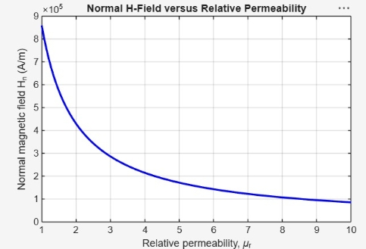
Test case (ii) Field Components and Refraction Angle at the Interface of Two Magnetic Media
Determine the field components, normal flux density and refraction angle in medium 2 for a specified
incident field and specified relative permeabilities.
MATLAB Program:
clc; clear;
mu0 = 4*pi*1e-7;
H1 = input('Enter magnitude of H1 in medium 1 (A/m): ');
th1 = input('Enter angle of H1 with the normal (deg): ');
mur1 = input('Enter relative permeability of medium 1: ');
mur2 = input('Enter relative permeability of medium 2: ');
H1n = H1*cosd(th1); % normal component in medium 1
H1t = H1*sind(th1);
% tangential component in medium 1
B1n = mu0*mur1*H1n; % normal flux density in medium 1
H2t = H1t; % tangential H is continuous (Ks = 0)
B2n = B1n; % normal B is continuous
H2n = B2n/(mu0*mur2); % normal H in medium 2
H2 = sqrt(H2n^2 + H2t^2);
th2 = atand(H2t/H2n);
fprintf('H1n = %.2f A/m, H1t = %.2f A/m\n', H1n, H1t);
fprintf('B1n = %.4e T\n', B1n);
fprintf('H2t = %.2f A/m, B2n = %.4e T\n', H2t, B2n);
fprintf('H2n = %.2f A/m, |H2| = %.2f A/m\n', H2n, H2);
fprintf('Refraction angle theta2 = %.2f deg\n', th2);
figure; plot([0 0],[-80 80],'k','LineWidth',2); hold on;
quiver(-H1n,-H1t,H1n,H1t,0,'b','LineWidth',2);
quiver(0,0,H2n,H2t,0,'r','LineWidth',2);
axis equal; grid on;
xlabel('Normal direction (A/m)'); ylabel('Tangential direction (A/m)');
title('Magnetic field at the interface of two media');
Sample Output: For H1 = 100 A/m, θ1 = 30°, μr1 = 1 and μr2 = 2, H1n = 86.60 A/m, H1t = 50.00 A/m,
B1n = 1.0883 × 10⁻⁴ T, H2t = 50.00 A/m, B2n = 1.0883 × 10⁻⁴ T, H2n = 43.30 A/m, |H2| = 66.14 A/m
and θ2 = 49.11°.
Verification: H2t must equal H1t, B2n must equal B1n, and tan θ2 / tan θ1 must equal μr2/μr1 (1.1547
/ 0.5774 = 2.00).
Observation: The tangential magnetic field and the normal flux density are continuous; the field line
bends away from the normal in the medium of higher permeability (θ2 > θ1).
Output:
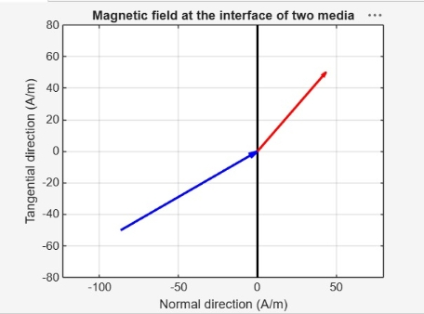
Test case (iii) Variation of the Refraction Angle with the Angle of Incidence for Different
Permeabilities
Plot the angle of the magnetic field in medium 2 against its angle in medium 1 for three values of μr2
with μr1 = 1.
MATLAB Program:
clc; clear;
th1 = linspace(0,89,179);
mur1 = 1;
mur2 = [2 5 10];
figure; hold on;
for k = 1:3
th2 = atand((mur2(k)/mur1)*tand(th1)); % tan(th2) = (mur2/mur1)*tan(th1)
plot(th1,th2,'LineWidth',2);
end
plot(th1,th1,'k--'); % mur2 = mur1 (no change of direction)
grid on;
xlabel('Angle in medium 1, \theta_1 (deg)');
ylabel('Angle in medium 2, \theta_2 (deg)');
legend('mur2 = 2','mur2 = 5','mur2 = 10','mur2 = 1','Location','southeast');
title('Refraction of the magnetic field at the interface');
Sample Output: For θ1 = 30°, θ2 = 49.11° (μr2 = 2), 70.89° (μr2 = 5) and 80.17° (μr2 = 10); for θ1 =
60° the values are 73.90°, 83.41° and 86.70°.
Verification: Every curve must satisfy tan θ2 = (μr2/μr1) tan θ1 and the μr2 = 1 curve must coincide
with θ2 = θ1.
Observation: A larger μr2 bends the field line further away from the normal; the direction is unchanged
at θ1 = 0° and 90°.
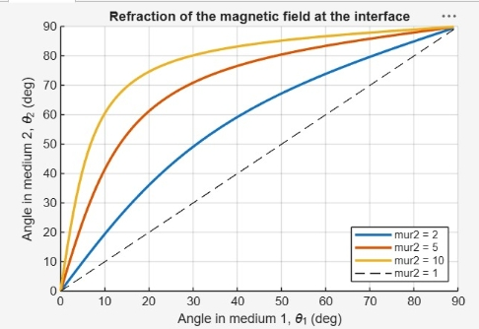
Test case (iv) Effect of the Relative Permeability on the Field Components in Medium 2
Keep the incident field fixed and vary μr2 to show which components are continuous across the
boundary.
MATLAB Program:
clc; clear;
mu0 = 4*pi*1e-7;
H1 = 100; th1 = 30; mur1 = 1;
H1n = H1*cosd(th1); H1t = H1*sind(th1);
B1n = mu0*mur1*H1n;
mur2 = linspace(1,10,100);
H2n = B1n./(mu0*mur2); % normal H in medium 2
H2t = H1t*ones(size(mur2)); % tangential H (continuous)
H2 = sqrt(H2n.^2 + H2t.^2);
B2n = mu0*mur2.*H2n; % normal B (continuous)
subplot(1,2,1);
plot(mur2,H2n,mur2,H2t,mur2,H2,'LineWidth',2); grid on;
xlabel('Relative permeability mur2'); ylabel('Magnetic field (A/m)');
legend('H2n','H2t','|H2|');
subplot(1,2,2);
plot(mur2,B2n,'LineWidth',2); grid on; ylim([0 2e-4]);
xlabel('Relative permeability mur2'); ylabel('B2n (T)');
Sample Output: For H1 = 100 A/m, θ1 = 30° and μr1 = 1, H2n = 86.60, 43.30, 17.32 and 8.66 A/m and
|H2| = 100.00, 66.14, 52.92 and 50.74 A/m at μr2 = 1, 2, 5 and 10; H2t stays at 50.00 A/m and B2n stays
at 1.0883 × 10⁻⁴ T.
Verification: H2t and B2n must stay constant for all μr2, and μr2 × H2n must equal μr1 × H1n.
Observation: The tangential H and the normal B are continuous across the boundary, while the normal
H falls as 1/μr2.
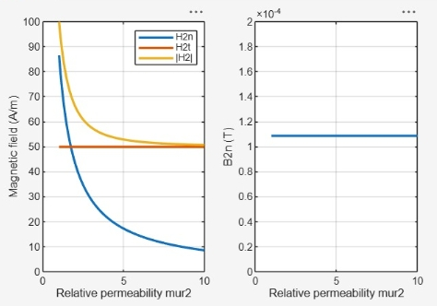
Result
Thus the program was verified for capacitance of parallel plate capacitor in different dielectric medium using MATLAB was successfully.
